Fractions- Children will be working towards:
Splitting a whole into smaller parts and explain that equal parts are the same size.
Using appropriate vocabulary to describe halves.
Share out items equally into smaller groups
Activities to help:
- When cutting up pizzas, cakes etc talk to your child about equal sized pieces. Cut into 2 equal sized pieces and explain each piece is a half.
- When working with bricks/counters/sweets etc share out a given number of bricks/counters/sweets equally between yourself and your child/children.
- When playing card games share the cards out equally. Talk about what you are doing.

Money: Children will be working towards:
Identifying all coins to £2.
Using 1p,2p,5p and 10p coins to pay the exact value for items to 10p.
- Take coins out of your purse. Ask your child to tell you what each coin represents. Ask your child to point to or pick out the 10p or any coin of your choice.
- Make up simple picture cards with ice creams/sweets/toys etc. Write on values up to 10p. Ask your child to pick a card and to pick out all the coins they would need to pay for the item.

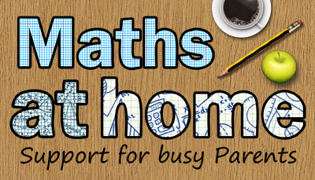
Mintlaw Cluster Schools
Supporting your child in Numeracy and mental agility
Stage 1
An awareness raising booklet – working in partnership

Numbers:
Children will be working towards:
Recognise that zero means there is none of a particular number and is represented by the numeral 0
Identifying and recognising numbers from 0-10 then 10-20.
Identifying the number before, the number after, the number in between.
Order all numbers (0-10 followed by 0-20) forwards and backwards.
Activities to help;
- Make number cards with the numbers 1-5,1-10 on them. Turn them face down. Take turns to turn them over and say the number on the card. If you say the correct number then you keep the card. If you don’t a player who correctly identifies the number gets the card. The person with the most cards at the end wins.
- Turn your number cards over randomly. Say the number on the card. Once all the cards have been turned over ask your child to place them in order.
- Have number cards including 0 and counters/sweets etc. Place the cards face down. Turn a card over and ask your child to give you the number of counters/sweets etc represented by the number on the card. When 0 appears discuss what this means.
- Pick a card. Ask your child if they can say the number before or the number after.

Numbers: children will be working towards:
Recognising that the amount is the same regardless of form
Understanding that the count does not alter when objects are rearranged.
Activities to help
- Have a variety of objects in front of you (dice, playing cards, counters, sweets etc). Choose a number 1-6. Show it on a dice, as a playing card, counters in a row. Discuss how the amount is the same even if it looks different.
- Place a certain number of counters in a row. Then rearrange into a circle or couple of rows. Discuss that there are still the same amount of counters.
Addition/Subtraction: children will be working towards:
Counting on and back in ones to solve addition and subtraction problems.
Combining 2 collections of items to make a total.
Activities to help
- Using colouring pencils/sweets/counters etc. Ask your child how many are there. Then what would happen if you had one more or 1 less.
- Using sweets/counters etc have 2 groups say 1 group with 2 sweets and 1 group with 3 sweets. Ask your child to join both groups. How much do you now have altogether?

