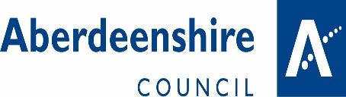 | 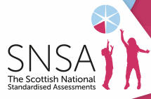

SCOTTISH NATIONAL STANDARDISED ASSESSMENT (SNSA)
Parent/Carer Information Leaflet

What is SNSA?
- From session 2017/18 the Scottish Government is introducing a new system of standardised assessments, called the Scottish National Standardised Assessments (SNSA), which will replace the variety of other standardised assessments that have been used until now in local authorities across Scotland. The new system will be delivered by all Aberdeenshire schools and will involve all children at the P1, P4, P7 and S3 stages of their education, focusing on aspects of reading, writing and numeracy.

What will SNSA involve in my child’s school?
- The assessments are completed online and will be automatically marked by the system, providing teachers with immediate feedback. The assessments do not have any pass/fail mark, as results are used to help teachers plan the next steps in learning for each child in order to help them make the best possible progress.
- SNSA is an adaptive system, which means that all pupils are challenged and receive an assessment suited to their ability. It is designed so that if a child is struggling with the initial questions being asked, it will make subsequent ones easier. Similarly, if the child copes well with the initial questions, it will make subsequent questions more challenging.
- Children do not have to revise or prepare for the assessments. They are designed to be used as part of normal teaching and learning and the information that they provide will be used in the same way as other assessment information which arises from day to day teaching and learning activities.
- The assessments do not have a time limit attached to them, however, the majority of children will complete an assessment in no more than 45 minutes. Pupils in P1 will take 2 assessments (one in literacy and one in numeracy) and pupils in P4, P7 and S3 will take three assessments (in reading, writing and numeracy).
- The assessments are designed, as far as possible, to be appropriate for use with all children. Children who require additional support will be able to receive the support they normally receive in the classroom when completing the assessments.
- Head Teachers and Teachers will determine, as part of their planning for the session as a whole, when the assessments will take place. Pupils and Parents/Carers will be notified when these are scheduled to take place by their individual school.

What does SNSA mean for Parents/Carers?
- The information that is generated from SNSA adds to the range of other assessment information arising from normal teaching and learning activity. As such, it is primarily designed to be used by teachers to assist them in identifying strengths and areas for development and for planning next steps in learning. As part of the range of assessment information available, SNSA will also assist teachers in assessing when key stages in learning, such as when a Curriculum for Excellence Level has been achieved.
- The information arising from SNSA will also play a role in informing the normal engagement processes with parents/carers (Parents’ Evenings, Reporting processes etc.) about their children’s learning, which will take place in each school.

Where can I find out further information about SNSA?
- The Scottish Government have created a dedicated website at https://standardisedassessment.gov.scot

If you have questions or concerns regarding SNSA,
please contact your child’s school in the first instance.

