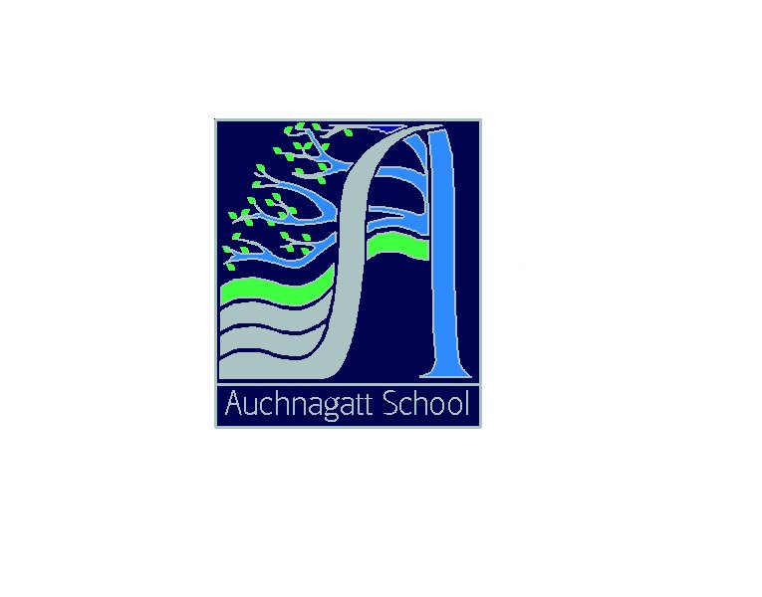

OCTOBER NEWSLETTER

Our vision for Auchnagatt School is a secure, happy place to learn where everyone is encouraged to take pride in themselves, those around them and their work and where everyone’s efforts are valued and celebrated.

Dear Parents/Carers

The term has flown past, I can’t believe we are already in the last week!

Techfest
P2 – 4 and P5 – 7 enjoyed a fantastic trip to Techfest on Wednesday 30th August. The day was packed with science and technology workshops and activities.

The P2 – 4s met some Amazing Animals and learned about their characteristics and habitat as well as learning about endangered species. In Bizarre Bones, as well as exploring the structure and function of bones, the children were able to handle some animal bones. For many the favourite was Dynamic Dentistry where the children learned about good oral hygiene and the effects of diet before becoming dentists, they had to extract teeth and clean and fill a decayed tooth.

The P5 – 7 class also experienced 3 workshops, in K-nex Towers the children explored the function of towers before learning about the forces of tension and compression and the importance of strong shapes and stability. They were then challenged to build the tallest, most stable tower with their box of K-nex. In the H2O Show they learned about the properties of liquids and gasses through fun demonstrations with bubbles, they also learned about Archimedes’ theory of displacement. Their favourite workshop was The Chemistry of Cooking where the children investigated some of the chemical reactions which occur during the cooking process and extracted DNA from a strawberry before making instant ice-cream using liquid nitrogen!

Reporting Calendar
Attached you will find a copy of this year’s Reporting Calendar giving details of all the reporting opportunities throughout the session.

Handwashing
As the colder weather approaches and children are often indoors more and in close proximity to each other could I please ask you to reinforce good handwashing practices, particularly after being to the toilet, before eating and if pupils are sneezing, blowing their nose etc. This is something we do reinforce in school and will be focusing on during our Food and Health week next term.

Pound Coins
As you know, old style pound coins are being removed from circulation as of 15th October when we will no longer be able to accept them. We have had our final secure pick up for this term and would really appreciate if any payment to the school office or kitchen does not include the old coins.


60th Anniversary
This term has seen the school celebrate its 60th Anniversary. All 3 classes have been looking into the history of the school and the surrounding area and it has been lovely to see the excitement and enthusiasm of the children as they share the findings of their research. It is also obvious that this has sparked a great deal of discussion and research at home. I would like to thank everyone who has shared their photos, memorabilia and memories. A special thanks go to Mrs Sheila Boyes (nee Dickie) and Mrs Helen Gill (nee Hay) who came to talk to all the classes about life in Auchnagatt School when they were here. Both ladies started as P1s in Auchnagatt in 1960 and the pupils were fascinated to hear about their experiences, things that have changed and things that have stayed the same.

Last Thursday saw us welcome past and present members of the Auchnagatt School Community to our 60th Anniversary Tea Party organised in conjunction with the School Council. The evening was a resounding success with lots people who have not been in our school for many years enjoying a trip down memory lane to look at the archive photos and artefacts on display as well as share a cup of tea and a chance to reminisce and talk to some of our current pupils and parents. Preparation for the eventing was a real team effort with pupils, parents, staff and friends of the school really pulling together. A huge thank you to everyone who contributed to the evening, I know not everyone who played a part in the organisation and preparation was able to come along on the night but your efforts are valued none the less. It is very clear that there are a great deal of talented bakers amongst our parents! Particular thanks to Mrs Mallarkey, Mrs McGowan and Mrs Robertson for their work in organising and preparing for the evening.

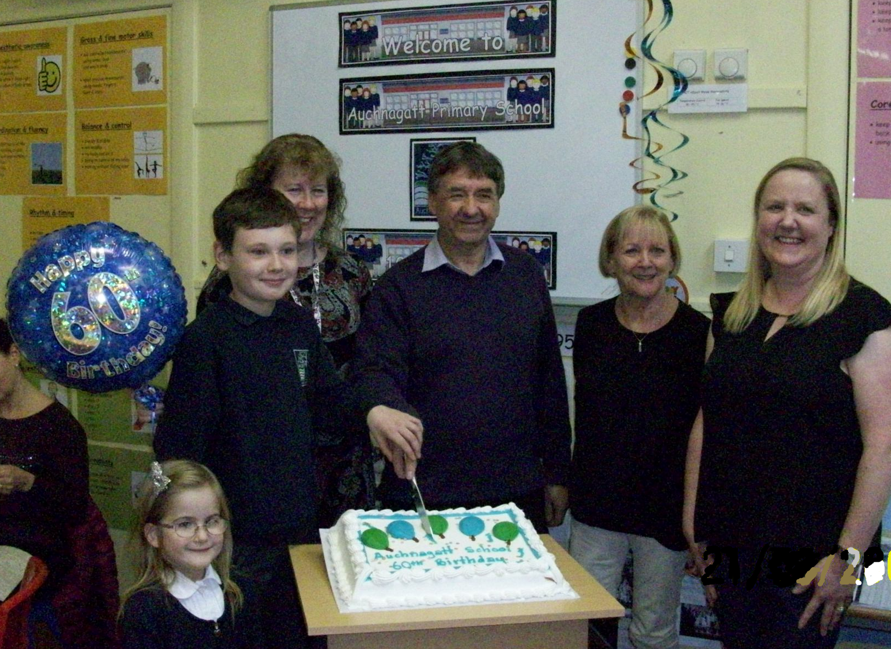
As not everyone was able to come along to the Tea Party we will keep the displays up until the next Community Café on Friday 24th November to give anyone who was unable to attend the Tea Party the opportunity to see them, the children will also sing the 2 songs they performed on the night. Please pass this information on to anyone you know who would be interested in this opportunity. The 24th November is an open morning where parents will again have the opportunity to visit their child(ren)’s class to see their work. There will also be a Fairtrade Stall selling a variety of Fairtrade items and gifts.

Jessie and Blair, current P1 and P7 pupils, Mr Jim Anderson and Mrs Sheila Boyes, former pupils and Mrs Jackie Mallarkey, Chairperson of the School Council all helped to cut the cake.

To round off our 60th Anniversary celebrations this Thursday we are having an Afternoon Tea Party for the pupils and staff where each class will share their learning about the history of the school and surrounding area as well as enjoy a piece of birthday cake.
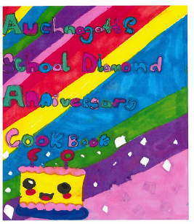
Cookbook Orders
Our 60th Anniversary Cookbook is now completed and in the process of being printed. Thank you to everyone who contributed recipes. Congratulations to Broghan in P5 who designed the winning cover. The standard of designs was very high and I am glad I was not making the choice on my own, all the covers are on display in the school. If you would like Cookbooks and have not yet placed your order, please get in touch with the school office. The books are being printed in batches and we will contact you once they are ready. We will also be selling them at the Community Café in November.

Extra French
Dr Sandra Turin, Thomas’s mum, is a native French speaker. She very kindly came in to school on Friday 6th October to teach the P2 – 4 class about France, French culture, where French is spoken and some French words and phrases. She also used a French children’s story to help extend the P5 – 7 pupil’s French vocabulary with some interactive activities.

Halloween Party
Just a reminder that the School Council have organised a Halloween Party for Tuesday 31st October from 4.30pm – 6.00pm. Entry is £4 and includes a snack and a drink. Please let the school office know if your child(ren) will attend the party, entry can be paid for at the door but we need to know how many children are coming. Please also ensure you leave a contact number in case you need to be contacted during the party.

Family Learning Event
You will have seen the Family Learning Event flyer for ‘Taking the Hell out of Homework’ on Tuesday 14th November in Mintlaw Academy from 7pm – 8.30pm presented by Neil Mackay from Action Dyslexia. This event is for parents and pupils from all the schools in the Mintlaw Network. Although the presentation is delivered by Neil Mckay from Action Dyslexia, this is aimed at all parents and pupils who find homework challenging, not solely for pupils who have dyslexic tendencies.

Improvement Planning
As discussed at the Parent Council, the schools combined Standards and Quality report for 2016/17 and the Improvement Plan for session 2017/18 is now completed. The main themes of this year’s Improvement Plan are; Early Years Literacy, Numeracy, Self-Evaluation, GIRFEC, Raising Attainment, Achievement, Assessment and Moderation, Curriculum Design, Digital Learning and Health and Wellbeing. Much of this work will be done at both school and cluster level. The document is available on the school notice board for parents to read and will shortly be available on the school website.

Book Bug/Read Write Count
Once again this year all pupils in P1 – 3 will receive a book bag. These packs are provided by The Scottish Book Trust, in partnership with Education Scotland and the Scottish Government and contain a variety of literacy and numeracy materials for parents to use with their children at home. More information and ideas for including literacy and numeracy activities into your daily routine can be found by following the links below:

http://www.scottishbooktrust.com/bookbug/bookbug-bags
http://www.readwritecount.scot/

Look out for these bags coming home during the week beginning 27th November.

Diary Dates
Mon 30 Oct | Start of Christmas Term
Tues 31 Oct | Tom Malcolm First Aid P5-7  Evening Express 10:30 P1 photo
Wed 1 Nov | Tom Malcolm First Aid P5-7 am
Mon 13 Nov | In Service
Tues 14 Nov | In Service  Taking the Hell out of Homework 7pm Mintlaw Academy
Fri 17 Nov | Literacy Jotters home
Mon 20 Nov | Road Safety week
Tues 21 Nov | Parent Council 7:15
Fri 24 Nov | Community Café and Fair trade
Thurs 30 Nov | Flu vaccine
Fri 1 Dec | Dr Turin P5-7 Rocks and Fossils  P2-4 Lego Towers
Mon 18 Dec | Santa
Tues 19 Dec | Panto – Aladdin
Wed 20 Dec | School show pm and evening
Fri 22 Dec | End of term
Mon 8 Jan 2018 | Start of Spring Term
Fri 9 Feb | Occasional day holiday
Mon 12 Feb | Holiday
Tues 13 Feb | In Service Day
Wed 14 Feb | In Service Day
Thurs 29 Mar | End of Spring Term
Mon 16 April | Start of Summer Term
Mon 7 May | Holiday
Mon 4 June | Occasional holiday
Fri 6 July | End of Summer Term
Tues 21 Aug 2018 | Start of Autumn Term

Wishing you all a safe and happy October Break.
Yours sincerely

Jill Thomson
Head Teacher

